MAYOR
Doug Haynie

COUNCIL MEMBERS
Cindy Bone
Jenny Buley
Debra Gammon
Tom Hays
Ron Smith
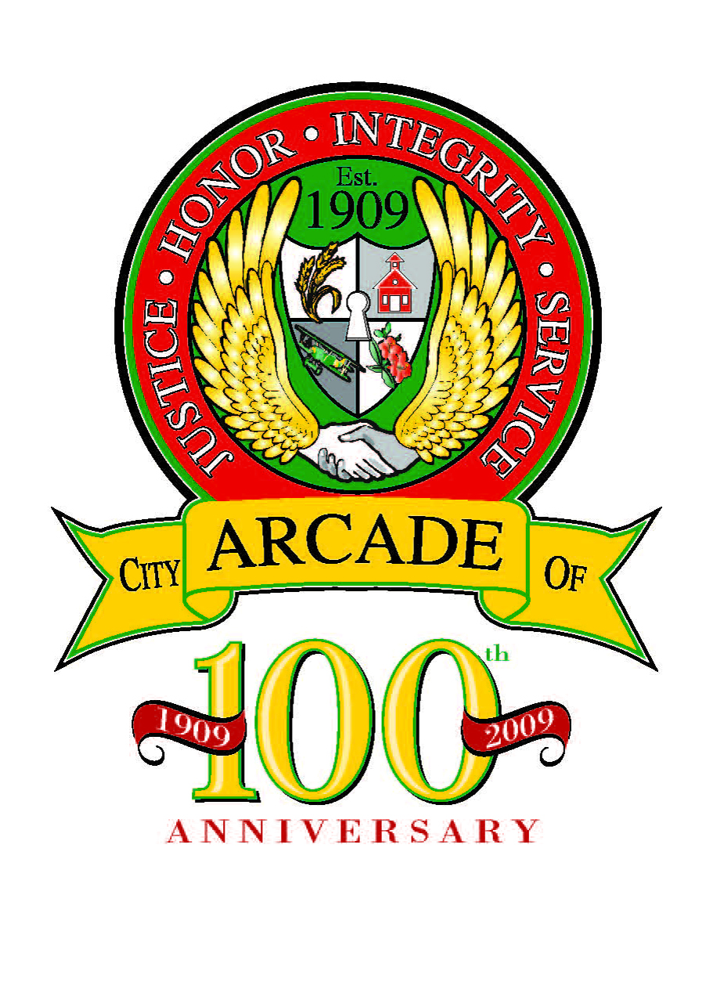

Approved Minutes
ARCADE CITY COUNCIL MEETING
September 12, 2022
7:00 P.M., CITY HALL
AGENDA

ORDER OF BUSINESS:

- CALL TO ORDER Mayor Doug Haynie

- ROLL CALL Mayor; Council Members D. Gammon, J. Buley, R. Smith, C. Bone, T. Hays
Also present, Administrative Assistant, Stephanie Johnson

- PLEDGE OF ALLEGIANCE led by Mayor Haynie

- REVIEW AND APPROVAL OF MINUTES FROM PREVIOUS MEETINGS:
- August 8, 2022 - City Council Meeting

Motion was made by Council Member Ron Smith to approve the unapproved minutes
of the August 8, 2022, City Council Meeting, as presented.

Seconded by Council Member Tom Hays Passed: Unanimously

5. REPORTS FROM STANDING COMMITTEES:
- Audit/Finance……………………………………………… Council Member C. Bone

Council Member Cindy Bone provided the July financial report as follows:

- Admin.: Rev.’s: $29,034 YTD: $169,030
Exp.’s: ($5,813) YTD: ($1,406)
Net Bal.: $23,221 YTD: $167,625
- Park/Roads: Exp.’s: $2,644 YTD: $11,319
- PD: Rev.’s: ($4,793) YTD: $22,295
Exp.’s: ($3,083) YTD: ($1,227)

The 2022 General Fund Operating Budget by the end of July had a Net Balance of
$17,989.00 and Year-To-Date balance of $200,012.00.

- SPLOST 6-July:
Total Rev.: $60,910 YTD: $303,184

Page 2
City Council Meeting
September 12, 2022

Council Member Cindy Bone provided the August financial report as follows:

- Admin.: Rev.’s: $19,280 YTD: $188,287
Exp.’s: $2,693 YTD: $1,288
Net Bal.: $21,974 YTD: $189,575
- Park/Roads:
Exp.’s: $3,371 YTD: $14,274

- PD: Rev.’s: $7,758 YTD: $30,053
Exp.’s: $2,702 YTD: $1,475

The 2022 General Fund Operating Budget by the end of August had a Net Balance of
$35,805.00 and Year-To-Date balance of $235,377.00.

- SPLOST 6-August:
Total Rev.: $54,694 YTD: $357,878

- Legal……………………………………………………………. Council Member R. Smith

Council Member Ron Smith reported that there was no legal activity for the month
of August 2022.

- Parks/Roads/Grounds…………………………………… Council Member T. Hays

Council Member Tom Hays reported that the last of the new HVAC Units have been installed. The sheetrock in the lobby of the police department is to be completed tomorrow, 9/13/2022.

- Special Events………….……………………………………. Council Member D. Gammon

Council Member Debbie Gammon reported we are hosting another Free Family Movie Night on Saturday, 10/22/2022. It will be a double feature with It’s the Great Pumpkin, Charlie Brown being the first movie. Since it is only 25 minutes long, we will have a 2nd feature film. We have created a poll on our Arcade City Hall Facebook page to get the local citizens opinion on the movie. In addition, ReRe’s Snowballs will be attending, and the East Jackson High School Wrestling Team will handle concessions.

Page 3
City Council Meeting
September 12, 2022

- Social Media …………………………………………………. Council Member J. Buley

Council Member Jenny Buley reported that we now have 500 followers to our Arcade City Hall page, and it’s growing every month. She will be posting some upcoming events including the Scarecrow Scrambler, Ambush Baseball, the police department’s Bicycle Rodeo that is coming up on October 8th, and highlighting September as being “Recovery Month” if it passes on tonight’s council.

- Police Department…………………………………............Chief Mike Adams

Chief Mike Adams provided the statistical report for the Month of August. In addition, Chief Adams is in the process of finalizing details of the Bicycle Rodeo to be held October 8th in the City of Arcade parking lots. He still needs volunteers to help with the rodeo. On October 15th, the police department will be participating in the Night of Lights which is being hosted by the Jackson County Sheriff's Office. And the police department will also be helping with our Family Movie Night on October 22nd.

- UNFINISHED BUSINESS None

- NEW BUSINESS:

a. Vote on RZ 2022-05 Rezoning from AG (Agricultural) District to C-2 (Highway
Commercial) District.

Motion made by Council Member Ron Smith to Approve the rezoning application for
RZ-2022-05 Rezoning from AG (Agricultural) District to C-2 (Highway Commercial)
District.

Seconded by Council Member Tom Hays Passed: Unanimously

b. Mary Campbell Requesting a Business License to Operate Delightful Companion
Home Care at 875 Hwy. 82 South, Jefferson, GA 30549

Motion made by Council Member Ron Smith to Approve the business license
request from Mary Campbell at 875 Hwy 82 South, Jefferson GA 30549 to operate
Delightful Companion Home Care, LLC in accordance with all City and LUMC ordinances.

Seconded by Council Member Jenny Buley Passed: Unanimously

c. Request for Contribution to Jackson County Community Outreach Program-22nd Annual
Achievement Awards Banquet

Motion made by Council Member Ron Smith to Approve a contribution of $400.00 to the Jackson County Community Outreach Program for the 22nd Annual Achievement Awards Banquet.

Seconded by Council Member: Cindy Bone Passed: Unanimously
Page 4
City Council Meeting
September 12, 2022

d. Proclamation for National Recovery Month September 2022

Motion made by Council Member Ron Smith to authorize the Mayor to sign the
Proclamation for National Recovery Month.

Seconded by Council Member: Tom Hays Passed: Unanimously

- CITIZENS REQUESTING TO SPEAK None

- OTHER BUSINESS None

- ADJOURNMENT

Motion was made by Council Member Tom Hays to adjourn the City Council Meeting.

Seconded by Council Member: Cindy Bone Passed: Unanimously

Approved minutes of the September 12, 2022, City Council Meeting/sbj


3325 Athens Highway ▪ P. O. Box 417 ▪ Jefferson, Georgia 30549 ▪ Phone: 706-367-5500 ▪ Fax 706-367-1914 www.cityofarcade.org

